

PROJECT PLAN & INCEPTION REPORT FOR THE SUPPLY, DELIVERY, INSTALLATION, TESTING, COMMISSIONING AND MAINTENANCE OF AN CASE MANAGEMENT SYSTEM (CMS)

(FRAMEWORK CONTRACT)

January 16, 2023

SUBMITTED BY:



Digital Imaging & Scanning International Ltd

**(DISI GROUP CONFIDENTIAL)**

**Abstract**

Inception Report for the Supply, Delivery, Installation, Testing, Commissioning and Maintenance of a Case Management System (CMS) for OFFICE OF DATA PROTECTION COMMISSIONER.

Distribution list: **Contract Implementation Team, Project Team**

**DOCUMENT HISTORY**

|  |  |  |
| --- | --- | --- |
| **VERSION** | **DATE** | **DESCRIPTION** |
| 01 | 16/01/2022 | First Draft |
|  |  |  |

*DISI and ODPC agree that this document accurately defines the complete scope of the Framework Contract requested under the ODPC Contract dated 09th January 2022 Ref: ODPC/OT/10/2022-2023*

|  |  |  |  |  |  |
| --- | --- | --- | --- | --- | --- |
| **Sign off Review Summary** | | | | | |
| **ITEM SUBMITTED BY – DISI GROUP** | | | | | |
| **REVIEW TEAM – ODPC Business Users Departments, Project Implementation Team, Project Team** | | | | | |
|  | **Name** | **User Department** | **Date** | **Signature** | **Comments** |
| 1 | Andrew Kiarie | Head of Supply Chain Management |  |  |  |
| 2 | Amos Kosgey | Head of Information Technology |  |  |  |
| 3 | Susan Waweru | Head of Legal Department |  |  |  |
| 4 | Oscar Otieno | Deputy Data Commissioner (Complaints, Investigations and Enforcement) |  |  |  |
| 5 | CIT Chair | Contract Implementation Chair |  |  |  |
| 6 | Nyambura Y. Njuguna | General Manager DISI |  |  |  |
| 7 | Carlos Agengo | Project Manager-DISI |  |  |  |
| **REVIEW COMMENTS:** | | | | | |

**Contents**

1. INTRODUCTION 7

2. PROJECT SCOPE MANAGEMENT 7

2.1. Functional Scope 7

2.2. Implementation Scope 9

2.3. Data Integration 9

2.4. ICT Scope 9

2.5. Change Management Scope 9

2.6. Scope Verification 10

2.7. Scope Control 10

3. PROJECT PLAN 10

3.1. Key Milestones and project plan: 12

4. HUMAN RESOURCES PLAN 13

4.1. Improving Competencies and Cohesion within the Project Team 15

4.2. Managing the Project Team 16

5. TRAINING MANAGEMENT PLAN 17

6. QUALITY MANAGEMENT PLAN 17

6.1. Quality Plan 17

6.2. Quality Control 17

6.3. Quality Assurance 17

7. COMMUNICATION MANAGEMENT PLAN 18

7.1. Managing Stakeholder Expectations 18

8. RISK MANAGEMENT PLAN 20

9. SUPPORT AND MAINTENANCE 23

9.1. Support 23

9.2. Maintenance 23

ANNEX 1: RESOURCE MANAGEMENT PLAN – PROJECT ROLES AND RESPONSIBILITIES 24

ANNEX 2: RESOURCE COMMITMENT 27

1. Business Users 27

2. Servers 27

ANNEX 3: PROJECT APPROACH 29

ANNEX 4: DETAILED WORK PLAN 47

ANNEX 5: ROLES AND RESPONSIBILITY MATRIX 50

ANNEX 6: TRAINING PLAN 52

ANNEX 7: HIGH-LEVEL SYSTEM DESIGN 55

Abbreviations

DISI Digital Imaging and Scanning International

CMS Case Management System (CMS)

LAN Local Area Network

SRS System Requirements Specification

UI User Interface

UAT User Acceptance Testing

ToT Training of Trainers

ODPC Office of the Data Protection Commissioner

TPS Tenant Purchase Scheme

SME Subject Matter Expert

API Application Program Interface

FSD Functions Specification Document

SSD System Study Document

COTS Commercial Off-the-Shelf Software

MS Dynamics Microsoft Dynamics

Definitions

“Vendor” DISI

“Customer” ODPC

# INTRODUCTION

The objective of this document is:

1. To provide a plan for the inception and management of the following services and products: - The legal case management system which will be designed to assist lawyers, legal teams, and court staff in managing and tracking legal cases. The system is intended to streamline the legal process, improve case organization and communication, and provide real-time access to case information.

* Supply a case management system that will provide a centralized location for case information, automate repetitive tasks, and provide real-time access to case information for all stakeholders.
* Implement and provide a platform for court staff to manage and track court cases, schedule court appearances, and process legal documents.
* Provide a case management system that will improve communication and collaboration among legal teams, court staff, and other stakeholders. The system will provide a secure platform for sharing case information and documents and will facilitate communication and coordination between legal teams and court staff.
* Improve the efficiency and effectiveness of the legal process and provide better access to justice for all stakeholders.

1. Allow setting out of timelines, benchmarks, and tools for project evaluation
2. Allow interested parties to understand their roles
3. Outline and agree on activity timelines for the project
4. Outline and agree on compliance timelines for the project

This document provides information on how the project will be initiated, planned, executed, monitored & controlled, and closed. The document consists of subsidiary management plans and other components in the sections below.

The document also provides rules and guidelines that must be observed by the project implementation team to ensure the project's success and should be available to the project implementation team for reference.

# PROJECT SCOPE MANAGEMENT

Project scope management ensures that the project includes all the work required and only the work required to complete the project successfully. Project scope management is primarily concerned with defining and controlling what is and is not included in the project's deliverables.

## Functional Scope

The scope of the implementation is limited to the Supply, Delivery, Installation, Testing, Commissioning and Maintenance of a Case Management System (CMS)

The system will include the following functionalities:

* Authentication and Authorization: Users will be able to log in to the system using their unique credentials and the system will have robust authentication and authorization features to ensure that only authorized users have access to the system and that they can only perform actions that they are authorized to perform.
* Case Management: Users will be able to create, manage and view cases within the system. Each case will have a unique case number and will be associated with a set of case-related data, such as the parties involved, the case status, and the court in which the case is being heard. The system will also allow for the creation of case profiles that contain detailed information about the case and its history.
* Case Parties Profiling: Users will be able to create profiles for advocates and magistrates involved in the cases. These profiles will contain information such as their contact details, qualifications, and case history.
* Court Profile: Users will be able to create profiles for courts involved in the cases. These profiles will contain information such as the court's location, jurisdiction, and case history.
* Management Tracking of Files Movement: Users will be able to track the movement of case files within the court system, which will provide real-time updates on the location of the case files and the status of the case.
* Administration of Legal Fees: Users will be able to administer legal fees for cases. This functionality will facilitate the calculation of legal fees for each case and provide the ability to generate invoices for the fees.
* Reports: The system will provide a set of predefined reports that can be generated based on user-specified criteria. The reports will provide detailed information about cases, such as the status of cases, the number of cases pending, and the number of cases that have been closed. Additionally, users will be able to create custom reports.
* Constraints:
* The system is designed for use in a legal environment and is not intended for use in other industries.
* The system's functionality is based on a set of assumptions about the legal process and may not be suitable for use in jurisdictions with different legal processes.
* The system is not intended to provide legal advice and should not be used as a substitute for the advice of a qualified legal professional.
* Assumptions:
* The system assumes that users have a basic understanding of the legal process and legal terminology.
* The system assumes that users will have access to the necessary equipment and infrastructure to use the system, including computers and internet access.
* The system assumes that users will receive the necessary training and support to use the system effectively.
* The system is designed with the assumption that users will maintain their data accuracy, completeness, and data security.
* This project scope will ensure that the system can be designed, developed, tested and implemented within the set timelines.

## Implementation Scope

This is limited to the Installation, Configuration and Phased Implementation of the above-specified functional scope in the following location:

1. Office of the Data Protection Commissioner Headquarters – Nairobi.

## Data Integration

One of the foundations on which the solution rests is the creation of powerful databases with updated and structured information to eliminate redundancies as much as possible. To do this, it is indispensable in the first place to identify all the core elements of the Enterprise Resource Planning System (MS Dynamics 365 Business Central), EDMS (OmniDocs) and the Complaints Portal that need to be integrated into the CMS.

The ODPC will be responsible for providing all the necessary information and access to its system to enable the CMS to integrate. Both the ODPC and DISI will be responsible for the verification of the data that is uploaded onto the system.

ODPC will liaise with the respective Enterprise Resource Planning System (MS Dynamics 365 Business Central) vendor, and/or any other systems vendor to collaborate with DISI to achieve the required integration

## ICT Scope

The ODPC will provide the hardware necessary to roll out the project in particular the following:

* **Reliable Internet Connection** to enable the Web App access via the Internet;
* The **Production Servers** that will run the proposed systems. This consists of the database servers and application servers.
* The **UAT server** for the test and training environment
* **VPN connection** (As per need) to allow for access to the UAT and Production environments where required.
* The **Backup Solution (Tape Library)** for ease of quick recovery and restoration whenever such a need arises.
* MS Dynamics 365 Business Central, EDMS (OmniDocs) and Complaints Portal **Restful APIs (Application Programming Interface)** for Integration with the CMS.

## Change Management Scope

Change Management will be the responsibility of both parties and all matters relating to change for the CMS will be executed by both parties.

## Scope Verification

Verifying the project scope includes reviewing deliverables for the individual project phases to ensure that each is completed satisfactorily and/or reasonable expectations that the deliverables can be met in subsequent project phases per the project implementation lifecycle. This process will be conducted by the Contract Implementation Team.

## Scope Control

Scope Control is focused on influencing the factors that create project scope changes and controlling the impact of those changes. Scope control assures that all requested changes and recommended actions are processed through an Integrated Change Control process, the project will execute scope control in accordance with Contract No. ODPC/OT/10/2022-2023 under Section B: Scope of the system.

The change control process is defined under Contract No. ODPC/OT/10/2022-2023 Section H: Changes to the System

# PROJECT PLAN

The following is a summary of the key milestones, project plan and time schedule indicating the milestones including the payment schedule.

The following is a summary of the implementation schedule for the project.

*Please see Annex 6 for a detailed training plan*

*-Workplan CMS Implementation - ODPC*

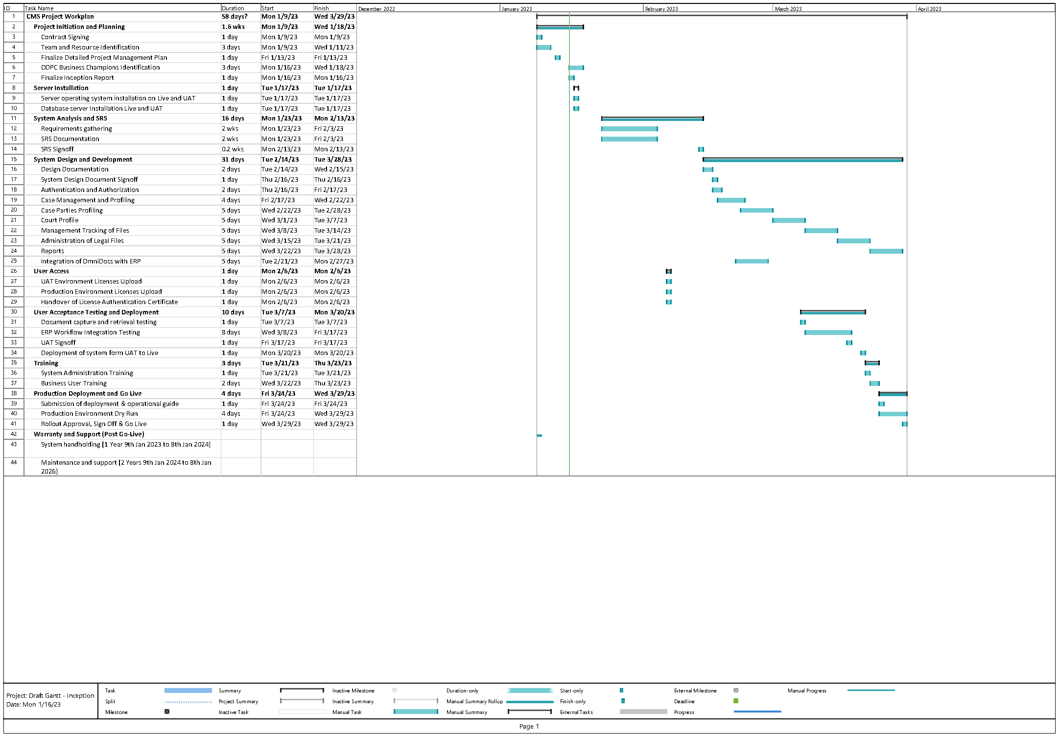

## Key Milestones and project plan:

# HUMAN RESOURCES PLAN

Human Resource Management is concerned with the aspect of managing resources on the project, as they roll on and off the project. The plan envisages engaging resources/team members in the project activities earlier enough to increase the likelihood of success. The focus of the Resource Management Plan is to develop and produce a productive, highly efficient, and effective team.

The following organizational chart defines the human resources required within the project.

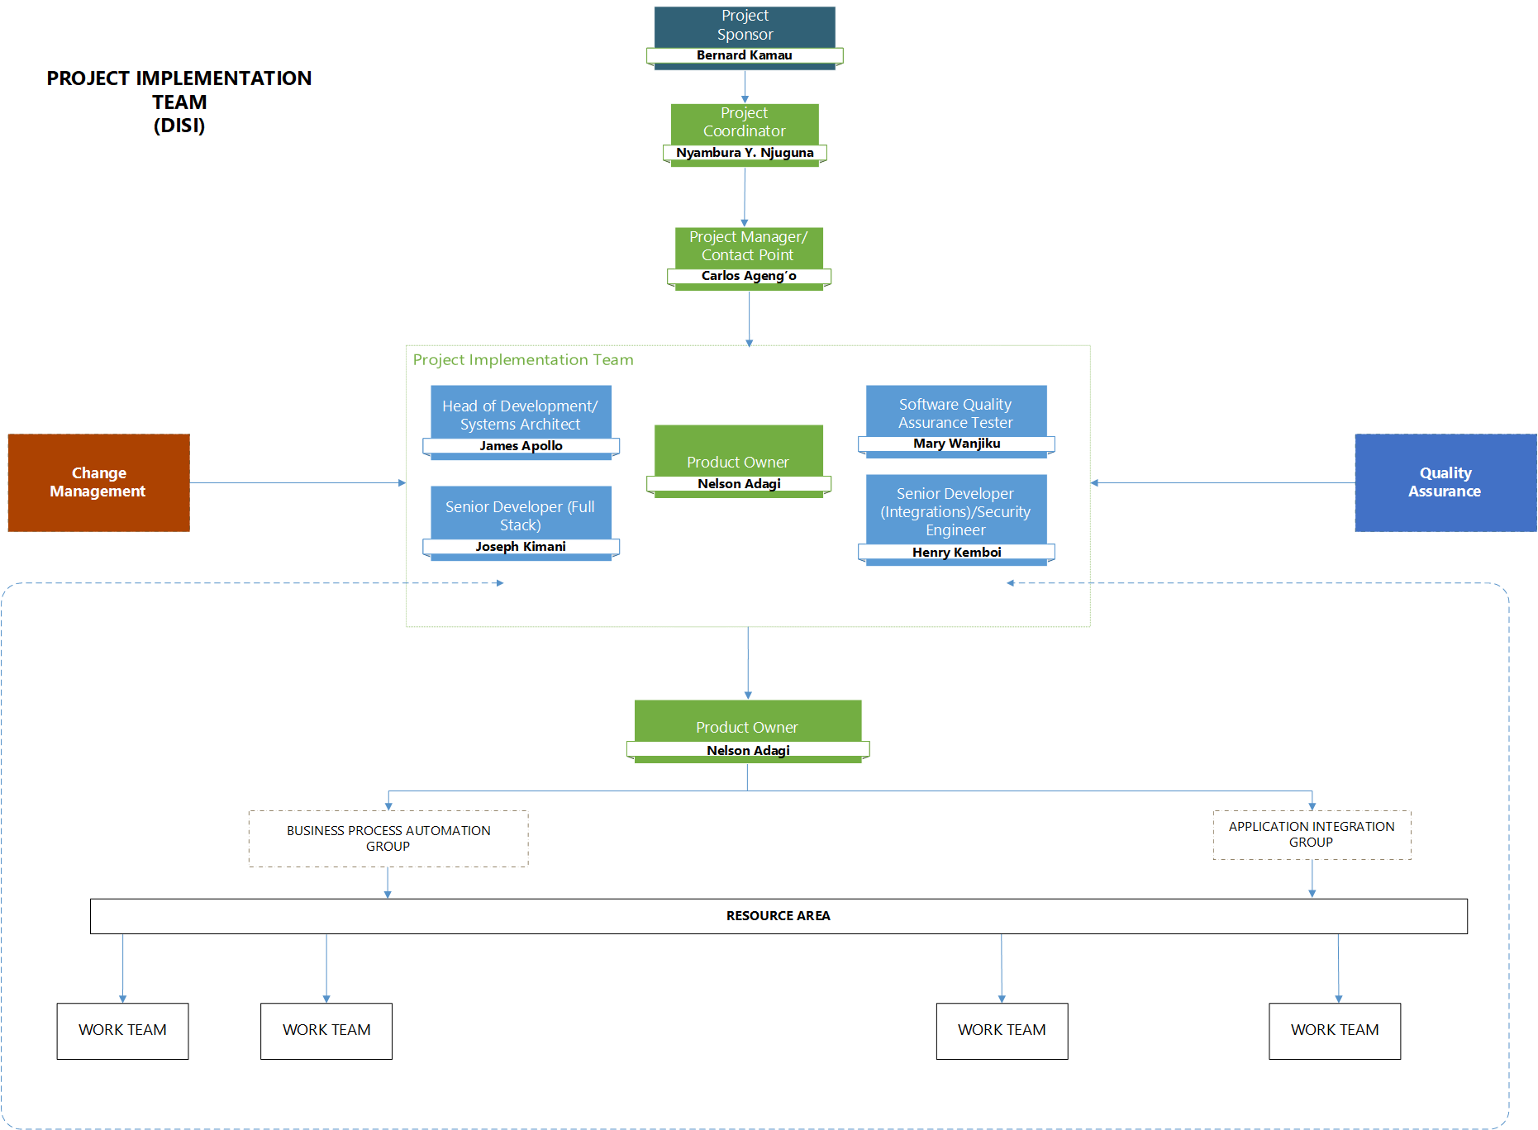

Please refer to ANNEX 5 for detailed information on the roles and responsibilities relating to the above structure.

The names of the persons in the above roles are;

|  |  |  |
| --- | --- | --- |
| **ROLE** | **DISI Group** | **ODPC** |
| Project Director & Coordinator | Nyambura Y. Njuguna  [Ynjuguna@disigroup.com](mailto:Ynjuguna@disigroup.com) | Contract Implementation Team |
| Project Manager | Carlos Ageng`o  [Cagengo@disigroup.com](mailto:Cagengo@disigroup.com) | Amos Kosgei |
| Product Owner | Nelson Adagi  [nmbajah@gmail.com](mailto:nmbajah@gmail.com) |  |
| Head of Development/Systems Architect | James Apollo |
| Senior Developer (Full Stack) | Joseph Kimani |
| Senior Developer (Integrations)/ Security Engineer | Henry Kemboi |
| Software Quality Assurance Tester | Mary Wanjiku |

The proposed project team should be available to perform their respective project role 100% as planned. The risk with not having this availability is that knowledge transfer from DISI is not performed effectively with the impact on the capability and competence of ODPC in the longer-term optimization and maintenance of the system and as a consequence the Total Cost of Ownership (TCO) which would go up if external consultants would be required for activities that the ODPC team would have been expected to perform if the knowledge transfer had been a success.

## Improving Competencies and Cohesion within the Project Team

Training courses have been included in the overall implementation schedule that will acquaint the ODPC project team with the product knowledge enabling them to participate effectively in the project activities.

Training will be planned in accordance with the training activities in the contract. For each training course identified, DISI will provide details of the course and tentative schedule for review with ODPC before commitment.

Team-building exercises will be incorporated during project team meetings and independently to promote trust and cohesiveness among team members to raise productivity through teamwork, e.g.

* Phase Kick-off Meetings
* Team Meetings
* Individual Team Building Sessions (if required)
* Phase Closure & Lessons Learned Meetings

Finally, the project managers will continually monitor and assess team performance to determine if development efforts need to be adjusted to improve the project team’s effectiveness.

## Managing the Project Team

The project organizational chart illustrated above sets out the reporting structure for the various project team members. ANNEX 3 of this document further outlines the responsibilities of team leaders with regards to monitoring and controlling the work performed by their team members.

An assessment of the competence of the trainers will be carried out in the Final Preparation. This will determine their ability and readiness to deliver quality training to the end-users.

It is important for ODPC through the Contract Implementation team to ensure a structure is in place for the sustainability and optimization of all the business areas of the implemented solution.

# TRAINING MANAGEMENT PLAN

Please see the Training Plan in ANNEX 6. as it follows the requirements of the Tender Specs.

# QUALITY MANAGEMENT PLAN

The Quality management plan focuses on defining the objectives for quality, how they will be applied and how they will be measured. Quality management and the creation of a quality management plan are key success factors for the project.

## Quality Plan

1. The quality plan must be defined, well communicated, executed, and controlled as the project moves through the phases from the blueprint to project sign-off. The quality of the deliverables must be approved to meet the stakeholder expectations to produce project success.
2. The Quality Management Plan is based on the successful completion of key project deliverables at the end of each major milestone as defined in the Project implementation schedule. An acceptance Testing Plan will be created that will ensure that project deliverables are assessed at the end of each project milestone to obtain stakeholder formal acceptance of the completed project scope and associated deliverables. Verifying the project scope includes reviewing deliverables for the individual project phases to ensure that each is completed satisfactorily and/or reasonable expectations that the deliverables can be met in subsequent project phases per the project implementation plan. This also includes the formulation of acceptance criteria for each deliverable by the Contract Implementation team.
3. A cutover document will also be produced with a checklist of the activities to be done before Go live.
4. **Project Reviews** provide a proactive quality assurance review, with an impartial analysis of all aspects of the project – across all project management disciplines, enabling early detection of project issues with actionable recommendations. The approach taken normally involves interviewing selected members of the Vendor and Customer Project Teams. A report is produced from the Review, which is presented back to Vendor and Customer. Key findings will be reviewed and discussed with the Project Leadership. If required, planning will be included for this type of review e.g., at the end of the Blueprint and/or Realization Phases.

## Quality Control

1. Each deliverable will be tested against the contractual requirement and any issues raised, logged, and prioritized in the issues log. The resolution of these issues will also be tested. If any change is required due to the testing, the change control process in the contract will be used.
2. The execution of the cutover checklist of activities will also be quality controlled ensuring the output of each activity is also checked.

## Quality Assurance

1. The process will be quality assured by both DISI and ODPC Contract Implementation team.

# COMMUNICATION MANAGEMENT PLAN

Communication Management is focused on planning for and ensuring the project's information needs are planned. Communications Management includes the processes of communications planning, information distribution, status reporting and stakeholder management. Project managers can and will spend an inordinate amount of time communicating with the project team, stakeholders, customers, and the sponsor. Everyone involved in the project should understand how communication affects it.

In order to promote better communication within the project, the following procedures will be implemented:

* Monthly project management team meetings. Each joint team will produce a project status report monthly which will highlight their key accomplishments for the current month and key objectives for the following month, risks and issues with individual mitigating activities, resources constraints, as well as a scorecard.
* Fortnightly workgroup meetings presenting business area progress and seeking decisions/approvals on issues affecting how ODPC will conduct business using the system
* Executive committee presentation to ODPC board members if required.
* Ad hoc reporting needs or requirements will be assessed on as is basis

The project too should strive to protect the environment and should aim to conserve the use of paper. To this effect, email communication of documents that need to be circulated is encouraged. A group email specific to the project team will be established.

In addition, a shared server location will be set up to act as the central repository for working project documentation and project records throughout the life of the project. Access will be restricted to project personnel only with varying levels of authorization.

## Managing Stakeholder Expectations

The project managers will be responsible for managing the expectations of the stakeholders. This will be conducted through a process of identifying the key stakeholders, their interest in the project and ensuring these are aligned with the objectives of the project.

To this effect, the project managers will work closely with the Contract Implementation team to ensure all stakeholder expectations are identified and managed accordingly.

Communication methods that will be utilized to manage stakeholders include:

* Face-to-face meetings
* Issues log – As stakeholder requirements are identified and resolved, the issues log will document concerns addressed and closed.
* Action item log
* Approved corrective actions
* Approved change requests

# RISK MANAGEMENT PLAN

The following are the major risks identified so far.

|  |  |  |  |
| --- | --- | --- | --- |
| **RISK CATEGORY** | **RISK DESCRIPTION** | **MITIGATION ACTION** | **RISK OWNER** |
| Technical | Non-availability of physical infrastructure at the Project Site | REDUCE:   * ODPC to ensure that infrastructure for Project Site is made available prior to the Project team’s arrival. | ODPC Program Director/Project Manager |
| Organization | Non-availability of ODPC’s core team members and related support teams during the current environment study and the subsequent phases as per the project plan drawn up / circulated | REDUCE:   * ODPC to ensure that core team members are freed from their regular responsibilities so that they can devote adequate time as per the project time requirements drawn up. * Any delays beyond acceptable timeframes which will have a bearing on the project timelines will be escalated by Vendor to ODPC’s Program Director calling for his intervention. * The same will be highlighted in the weekly/monthly meetings and if the impact of the same is considered high then project plan will be suitably re-drawn up along with the related commercials involving a “Change Request Note.” * The same will be forwarded to ODPC’s Program Director and will also be presented before the Project Steering Committee. | ODPC Program Director/Project Manager |
| Organization | Lack of buy-in from stakeholders | REDUCE:   * Identify key stakeholders and make them aware of their role in the change process. * Support leaders to communicate the vision, strategy and objectives of the project and motivate people and lead the process of change. | ODPC Program Director/Project Manager |
| Organization | Vested interests may result in the creation of obstacles to the implementation process. | REDUCE:   * Identify each stakeholder, understand their goals and expectations, and address them. * Make stakeholders aware of the relevance of their role in the process of change. * Ensure stakeholders receive communication on what is relevant to them. | ODPC Program Director/Project Manager |
| Organization | Data conversion process may reveal inadequate or inaccurate information | REDUCE:   * Ensure an early start of master data collection. | ODPC Program Director/Project Manager/ODPC’s Core Team Members/Vendor |
| Organization | Training attendance may be below expectation | REDUCE:   * Ensure early identification of super-users and end users. * Ensure plans for business continuity in operations while training takes place for the end-users. * Conduct an assessment of end-user basic computer skills and plan for training if required. | ODPC Program Director/Project Manager/ODPC’s Core Team Members |
| Organization | Lack of coordination  among vendors thus delays  in delivery of the  components required for  integration | REDUCE:   * ODPC’s management to intervene with vendor’s senior management to ensure proper support is available to meet the project timelines. * ODPC’s needs to identify point of contact of each vendor & any delay impacting the project delivery dates will be escalated as per the Escalation Matrix. | ODPC’s Program Director/Project Manager project / Respective Vendor team Project Sponsor |
| Organization | Delay in providing  document  approvals/Signoff’s as per  the project timelines  Involvement of senior management is required to  ensure approvals are provided as required within  the timelines identified | REDUCE:   * ODPC’s Core team members to work closely with our team at every stage so that project delivery, approval and review mechanism will be hastened. | ODPC’s project sponsor/ ODPC’s Program director / ODPC’s Core Team Members |
| Technical | Delay in Site (UAT &  Production) readiness | REDUCE:   * Needs to ensure that all the required H/W, S/W are timely delivered as per the specification mentioned in the site readiness check list & as planned. | ODPC’s Core Team Members /Vendor |

# SUPPORT AND MAINTENANCE

Support and maintenance are crucial components of this project, as they will ensure that the implemented CMS system remains operational and functional over time. The plan aims to ensure that the system and the WB run smoothly by the following:

* Minimal interruptions to daily activities
* Speedy recovery from unavoidable issues
* Rapid replacement of failed hardware
* Application Software Support Services

## Support

* Technical support will be provided during regular business hours, with a guaranteed response time of no more than 2 hours for critical issues.
* A dedicated support email address and phone number will be provided to ODPC for reporting issues and requesting assistance.
* Regular software updates and bug fixes will be released to address any issues that are identified.

## Maintenance

* A maintenance plan will be implemented to proactively identify and address potential issues before they become critical.
* Regular system backups will be performed to ensure that data can be recovered in case of a disaster.
* A disaster recovery plan will be in place to minimize downtime in case of a major incident.

Overall, the support and maintenance plan is designed to ensure that the system remains reliable and efficient over time. By providing prompt technical support and proactively addressing potential issues, we aim to minimize downtime and ensure the satisfaction of our customers.

# ANNEX 1: RESOURCE MANAGEMENT PLAN – PROJECT ROLES AND RESPONSIBILITIES

A Steering Committee will be constituted to oversee the overall performance of the application development as outlined in this proposal. We recommend that the committee consist of the Program Director and Project Manager from ODPC and Project Manager from DISI. This committee will be responsible for providing direction to the project team.

The details on the roles and responsibilities of the key members of the team are as follows:

|  |  |
| --- | --- |
| ODPC | |
| Role | Responsibilities |
| Contract Implementation team | Set the overall Program goal, identify team members,  Approves Program budget  Identifies the fit of the project in the overall Program, Set the overall Project objectives, identifies project inter- dependencies and addresses program bottlenecks, keep track of if the Project objectives are met. Addresses burning issue if there is any |
| Project Manager | Act as primary contact for resolution of any issues and queries raised by Vendor. Establish communication channels and protocols for discussions with stake holders, 3rd party application vendors, and Business & Technical Experts.  Arrange meetings/interviews with the users and management representatives mainly in the requirement gathering and user acceptance stages. Facilitate sign-off for deliverables. |

|  |  |
| --- | --- |
| DISI | |
| Role | Responsibilities |
| Project Coordinator | Provide overall oversite of the project implementation team.  Assist the Project Managers in the daily management of the project including planning for and monitoring & controlling project activities, resolution of issues raised, maintenance of project logs and ensure that the project is running within the prescribed constraints of cost, time, and quality. |
| Project Manager | Manage linkage with the system business users, ODPC project management and the development team  Act as primary contact for the resolution of any issues and queries raised by the Client.  Ensure the realization of the desired project results and the daily management of the project. Anticipate deviations from the project direction and carry out the necessary corrective measures immediately  Establish communication channels and protocols for discussions with stakeholders  Organize meetings and provide project status reports |
| Product Owner/Technical Leader | Shall manage all project activities including functional specification design, process designing, quality assurance, integration testing, and rollout |
| Functional Consultant/Trainer | Requirement understanding & functional specifications design for the solution.  Responsible for UAT and process rollout and mentoring services.  Responsible for UAT and process rollout, User training, Document manuals and Providing input to the development team. |
| Database Developer/Administrator | Manage database security/integrity and backup procedures Implement security measures Testing and modifying databases to ensure that they operate reliably Database design and development Liaising with programmers, applications/operational staff, IT project managers and other technical staff |
| System Integration Expert | Run performance test scenarios, track and report on key performance metrics. Document slow performing application areas and determine bottlenecks and opportunities for performance enhancements. Tune systems for optimal performance and characterize systems on multiple platforms. Handle performance test environment to build deployments, performance test data, scripts, and tools. Maintain systems integrity by defining requirements architecture. Support project lifecycle from commencement to completion. Coordinate with client and team members and resolve issues, reduce risk and enhance user satisfaction. Suggest test and evaluation strategies for major systems installations. |
| Web-based System Developer | Create Responsive sites as per business needs Creation of forms for workflow, CMS  Gather requirements from business users |
| Security Expert | Regularly perform security checks, Penetration testing and troubleshooting Suggest and implement solutions for improvement during the development cycle Track existing processes and offer solutions for improvement Implement new processes with the goal to optimize company's security system Work with the development team to ensure adherence to security matters Perform regular audits and provide reports |
| System Architect | Collaborating with project team and business users to determine business specific application needs. Leading the system development team and supervising the design, testing, and modification stages. Demonstrating application prototypes and integrating user feedback. Writing scripts and code for applications, as well as installing and updating applications. Running diagnostic tests and performing debugging procedures. Performing application integration, maintenance, upgrades, and migration. |

# ANNEX 2: RESOURCE COMMITMENT

For the project's successful implementation, the Vendor will require ODPC to dedicate some resources.

## Business Users

We recommend that ODPC liaise with the respective departments that shall be onboarded on the CMS platform to provide the subject matter experts. These users will be involved in the Requirements gathering/Analysis, UAT and training phases of the project.

## Servers

It is recommended that at least 2 sets of server environments be provisioned for the installation of CMS. The environments will cater for development/Integration/testing/training and Live/Production environment. The recommended specifications for each set of environments are listed below:

|  |  |  |  |  |  |  |  |  |
| --- | --- | --- | --- | --- | --- | --- | --- | --- |
| SYSTEM SPECIFICATIONS | | | | | | | | |
| SI. No. | **Type** | **Machine Type** | **vCPU** | **Operating System** | **Database** | **Other Software** | **RAM** | **HDD** |
| 1 | Production | Application Server & Management Server & Webserver | 4 core | CentOS 9 x64 | MySQL | NGINX | 24GB | 2 TB |
| 2 | UAT | Application Server & Management Server & Webserver | 4 core | CentOS 9 x64 | MySQL | NGINX | 32GB | 500 GB |

# ANNEX 3: PROJECT APPROACH

The following section describes the various phases of the Vendor’s Implementation Methodology and dependencies on ODPC to achieve live running of the system as per schedule.

|  |  |  |
| --- | --- | --- |
| PROJECT KICKOFF | | |
| Description | In this phase, Vendor will review the project management plan with ODPC.  Through these processes, Vendor will ensure that the project monitoring, controlling, and reporting mechanisms are defined and established at the start of the project.  This phase will also see the finalization of following:   * Project Team * Role & Task Assignments * Scope * Project Plan & Schedule | |
| Key Pre-Requisites | Contract and Scope of Work signed by ODPC | |
| Key Activities | **DISI** | ODPC |
| Description | * Set up process and reporting tools. * Define change management process. * Prepare high-level project plan * Address work location and equipment needs. * Review high level project plan and risk management plan. * Carry out risk analysis and mitigation planning. | * Set up a Contract Implementation Team * Identify stakeholders, Business & Technical Experts. * Establish communication channels and protocols for discussions with stakeholders, 3rd party application vendors, and Business & Technical Experts. * Clarify issue resolution and project setup requirements. * Finalize monitoring and status reporting approach. |
| Critical Success Factors & Key Challenges | * Commitment and availability of ODPC’s resources. * Regular review of risk and scope. * Communication between all stakeholders. * Joint status reporting and project planning. * Sign-off on project scope. | |
| Deliverables | * Organization Chart. * High Level Project plan. * Risk & Mitigation plan. * Role & Responsibility Matrix. * Escalation Matrix. * Change Management Process. | |

|  |  |  |
| --- | --- | --- |
| CONFIGURATION AND INSTALLATION | | |
| Description | After the multiple iterations in the Development & Testing phase, the workflows will be released for deployment, integration & configuration at Client’s onsite Development/testing site. | |
| Key Pre-Requisites | * Development/testing Environment. * Executed Site Readiness checklist by ODPC. * Delivery of components required for integration by the 3rd party application vendor. * Completion of Coding, Unit Testing and QA (Quality Assurance) Testing activities | |
| Key Activities | **DISI** | ODPC |
|  | * Deploy the Product, process & components on test environment. * Integrate with the external systems. * Interface testing | * Create Development/testing environment. * Assist Vendor in deploying the application in the environment. * Ensure that the components required for integration have been delivered by the 3rd party application vendor. * Provide clarifications on issues and unexpected results. * Coordination among vendors/team involved in integration. |
| Critical Success Factors & Key Challenges | * Executed Site Readiness checklist by ODPC. * Delivery of component required for integration by the 3rd party application vendor. * Coordination among vendors/team involved in integration. * Adherence to agreed timelines | |
| Deliverables | Product processes & components integrated with External systems. Configuration Manual. Release Note. | |

|  |  |  |
| --- | --- | --- |
| INITIATION-REQUIREMENT ANALYSIS | | |
| Description | During this phase, a team of Vendor staff (business analysts, technical specialists, and domain experts), will collaborate with ODPC’s Business Experts to better understand the objective and derive the to- be requirement from the as-is business functionality. Sessions will be conducted with the Business and Technical experts. | |
| Key Pre-Requisites | * Availability of the ODPC’s business team, 3rd party application vendors, Subject Matter & Technical Experts for detailed discussion on the business requirements & reviews. * Client’s AS-IS Document for each process under the current scope. * Availability of Client’s security guidelines if there are any. * System Architecture & technical document of existing systems that the application will interface. * Adherence to industry standard quality practices such as ISO 9001, etc. * Frequent Reviews, * Adherence to the Quality Standards defined by Vendor & frequent audits by the designated Quality team | |
| Key Activities | **DISI** | ODPC |
| Description | * Base Product Demo * Joint requirement planning sessions with ODPC to understand and capture current business processes. * Comprehend Client’s requirement and vision of the future system. * Joint meeting with Client’s team to identify gaps in the existing system. * Joint meetings with Client’s business team, 3rd party application vendors, Subject Matter and Technical Experts to generate Process diagrams, Architecture Diagram, Data element Identification, Integration points & Business rules identification. * Address Non-functional requirements. * Obtain Missing information and conflict resolution. * Identify security, statutory, regulatory and performance requirements. * Identify product components which are to be integrated. Identify the product component integration sequence. Record the rationale for decision for final selection of integration sequence. * Identify the integration methodology and design interfaces with the external systems, in terms of the communication protocols, messaging format, and so on. * Identify interfaces with the external systems, in terms of the communication protocols, messaging format, and so on. * Prepare System Study Document / Process document. * Initiate Functional Specification * Document phase | * Making available the required infrastructure for the Onsite team. * Ensuring the availability of the Client’s business team, 3rd party application vendors, Subject Matter & Technical Experts for detailed discussion on the business requirements & reviews. * Provide System Architecture & technical document of existing systems that the application will interface. * Review and sign-off of the Requirement Specification/TO BE Process document & Detail Project Plan form the authorized Business & Technical team expert. |
| Critical Success Factors & Key Challenges | * Availability of AS-IS process, security guidelines, System Architecture & technical document of existing systems that the application will interface. * Availability of the ODPC’s business team, 3rd party application vendors, Subject Matter & Technical Experts for detailed discussion on the business requirements & reviews. * Availability of the ODPC’s team for Vendor ‘s Product Demo. * Adherence to industry standard quality practices such as ISO 9001, * Frequent Reviews * Adherence to the Quality Standards defined by Vendor & frequent audits by the designated Quality team. | |
| Deliverables | * System Study Document /TO-BE Process Document * Gap Analysis * Feature Traceability Matrix | |

|  |  |  |
| --- | --- | --- |
| FUNCTIONAL SPECIFICATION DESIGN | | |
| Description | Functional specifications design phase is a process to identify in detail the product/system inputs, outputs, and the software and hardware implementation requirements needed to create the product/system functionality and meet the product’s performance criteria as per the expectation of the customer, specified in System Study Document. It details what the finished product will do, how a user will interact with it, and what it will look like. This phase also focuses on the translation of business requirements into detailed technical requirements to facilitate development. | |
| Key Pre-Requisites | * Signed Off System Study Document/ Process Document. * Availability of the ODPC’s teams for clarifications if any | |
| Key Activities | **DISI** | ODPC |
| Description | * Identify systems, sub-systems, their components, and interconnections between them and how they will be integrated. * Identify any third-party components (COTS) (External to project) to be used in the design. The decision to acquire a product/product component or to make one can be decided on “make or buy” analysis * Identify reusable components if any. * Prepare Functions Specification Document. * Prepare Hardware & Bandwidth sizing sheet. * Prepare Deployment Diagram/Architecture. * Sets up Baseline coding standards. | * Provide clarifications on issues and doubts. * Coordination among vendors/team involved in developing components required for integration. * Review and sign off Functions Specification Document. * Review and sign off Hardware & Bandwidth sizing sheet. * Review and sign off Deployment Diagram/Architecture. * Review and sign off interface document. * Review & signoff of Functional test cases. |
| Critical Success Factors & Key Challenges | * Availability and completeness of System Study Document. * Adherence to industry standard quality practices such as ISO 9001, etc. * Frequent Reviews. * Adherence to the Quality Standards defined by Vendor & frequent audits by the designated Quality team. | |
| Deliverables | * Functions Specification Document. * Interface document. * Updated Feature Traceability Matrix. * Functional Test Cases. * Site Readiness checklist | |

|  |  |  |
| --- | --- | --- |
| PROCESS DESIGN AND DEVELOPMENT | | |
| Description | The design and development of process will commence upon the completion of Function design phase. The process/components will be developed and configured as per the signed off SSD and FSD. The development and unit testing activities will be carried out primarily from Vendor ‘s offshore development center. | |
| Key Pre-Requisites | * Availability of the ODPC’s teams for clarifications if any * Signed off interface document. | |
| Key Activities | **DISI** | ODPC |
| Description | * Prepare High level internal specification document. * Prepare Low level internal specification document. * Develop and document unit test plans for all components. * Develop the code (module/unit) as per the coding guidelines/standards. * Baseline Code (Code Baseline) before doing Unit Testing Code reviews. * Perform the unit tests and fix any bugs identified during the unit testing. * Baseline Code (Code Baseline) before doing Unit Testing. * Keep track of issues, weekly status, and progress. | * Provide clarifications on issues and doubts. * Provide realistic test data * Coordination among vendors/team involved in developing components required for integration. * Ensure that ODPC will facilitate the 3rd party vendor necessary support, required for integration. * If required can perform document reviews for randomly selected sample components |
| Critical Success Factors & Key Challenges | * Configure and develop the process as per exact business requirements. * Exhaustive peer review of the code components. * Check-in the corrected code file in source repository and intimate the reviewer. * Reviewer verifies the corrections made against the defects and update Defect Database. * Timely resolution of issues related to business logic and any such issue involving the business users | |
| Deliverables | * High level internal specification document. * Units Test Plan & Cases * Unit tested code. * Unit test scripts and test logs * Configuration manual | |

|  |  |  |
| --- | --- | --- |
| TESTING | | |
| Description | QA test execution will be carried out by DISI ‘s QA Testing Team. The objective of this phase is to test the functionality across the modules and interfaces in a structured manner, with the intention of finding errors, during a Software Development Lifecycle. The application will undergo regression testing after fixing the reported issues. | |
| Key Pre-Requisites | * Signed off interface document. * Signed off functional test cases. * Availability of the QA test environment * Unit tested code. | |
| Key Activities | **DISI** | ODPC |
|  | * Prepare Test Plan. * Prepare Test Cases. * Deploy the application in the QA test environment. * Execute Test Case. * Log the defect and its severity into Bug Database. * Carry out QA testing. * Fix issues reported during the testing process. * Submit tested code for Onsite Release. | * Provide realistic test data. * Provide clarifications on issues and unexpected results. |
| Critical Success Factors & Key Challenges | * Test Plan & Test Cases. * Quality of test data. * Test coverage. * Well-structured issue resolution and change management mechanism. | |
| Deliverables | * QA test scripts and test logs. * Release of QA tested application/process/component. * Known issues / bug list. * Release note. * Product Manuals | |

|  |  |  |
| --- | --- | --- |
| SYSTEM AND INTEGRATION TESTING | | |
| Description | The objective of this phase is to test the functionality across the modules and the interfaces present in the system. The application will undergo regression testing after fixing the issues. This phase ensures that the system is performing as per the agreed upon FSD. | |
| Key Pre-Requisites | * Availability of representatives from ODPC’s key technical and business team members for testing. * Functional test cases | |
| Key Activities | **DISI** | ODPC |
|  | * Conduct performance Testing. * Assist ODPC during the testing phase. * Log the defect and its severity into Bug Database. * Fix issues reported during the testing process. | * Ensuring the availability of testing team. * Coordination among vendors/team involved in integration. * Integration testing Signoff |
| Critical Success Factors & Key Challenges | * Functional test cases. * Availability of end users to carry out the testing. * Sign-off of UAT phase | |
| Deliverables | * UAT tested application. * Updated Release Note. * Configuration & User Manual. | |

|  |  |  |
| --- | --- | --- |
| TRAINING | | |
| Description | Training will be provided by DISI to ODPC Administrators, Technical & Business users during implementation. Train the Trainer methodology shall be adopted. | |
| Key Pre-Requisites | * Signed off UAT Acceptance Document. * User Manuals. * Infrastructure required for imparting training. * Availability of end users. | |
| Key Activities | **DISI** | ODPC |
|  | * Prepare training plan in coordination with ODPC. * Provide Training. | * Assist Vendor in preparation of training plan. * Provide infrastructure required for imparting training. * Identify the Users. * Publish the schedule. * Training Signoff. |
| Critical Success Factors & Key Challenges | * Availability of the end users. * Training Plan * Infrastructure required for training. | |
| Deliverables | * Training Signoff | |

|  |  |  |
| --- | --- | --- |
| USER ACCEPTANCE TESTING | | |
| Description | ODPC will carry out acceptance testing (UAT) during this stage. In this test cycle ODPC is expected to test the application for conformance to both functional and non-functional requirements | |
| Key Pre-Requisites | * Signed off Integration Acceptance Document. * Availability of end users to carry out the Acceptance testing. * UAT Environment. * Client’s Acceptance test script/cases. * Availability of end users to carry out the Acceptance testing. * Training Manuals | |
| Key Activities | **DISI** | ODPC |
|  | * Assist ODPC during the testing phase. * Log the defect and its severity into Bug Database. * Classify issues along with Client’s team. * Fix issues reported during the testing process. | * Create UAT environment. * Assist Vendor in deploying the application on UAT environment. * Ensure that the components required for integration have been delivered by the 3rd party application vendor. * Provide clarifications on issues and unexpected results. * Coordination among vendors/team involved in integration. * UAT Signoff. |
| Critical Success Factors & Key Challenges | * Availability of the end users. * Training Plan * Infrastructure required for training. | |
| Deliverables | * Training Signoff | |

**TESTING FRAMEWORK**

We propose using the Testing Framework below, which has been followed by us as standard practice.

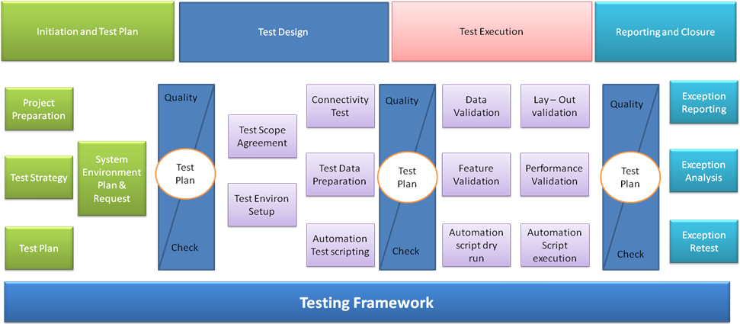

Figure: Testing Framework

As shown above, the entire project testing life cycle comprises of the following phases:

1. Initiation and Test Planning
2. Test Design
3. Test Execution
4. Reporting and Closure

|  |  |  |
| --- | --- | --- |
| Stage I: Initiation and Test Planning | | |
| *Entry Criteria* | *Phase Objective* | *Exit Criteria* |
| High level signed off requirement document available. | * Identification of Test Items * Identification of Test Scenarios * Planning Test Schedules, Milestones etc. * Plan for Manual and Automation Testing (if applicable) * Testing Estimation to be revisited | * Finalization of Test strategy * Finalization of Test Schedule * System Test Plan |
| Stage II: Test Design | | |
| *Entry Criteria* | *Phase Objective* | *Exit Criteria* |
| * Approved System Test Plan * Requirements Specifications * Process Use Cases | * Test Case preparation * Test data preparation * Traceability Matrix * Test case reviews and Approval * Base lining under Configuration Management tool * Test Bed installation and configuration * All the Software/ tools Installation and configuration | * Approved Test Cases * Requirement Traceability Matrix |
| Stage III: Test Execution | | |
| *Entry Criteria* | *Phase Objective* | *Exit Criteria* |
| * Approved Test Case * Approved Requirement Traceability Matrix * System testing environment is ready. * System Test Data is available * Unit Testing on the build is completed successfully. * Unit & Integration test result with signoff | * Executing Test cases * Capture, review and analyze Test Results. * Raise the defects and tracking them till closure | * All test cases have been executed. All defects found have been tracked into the defect-tracking system. * All critical and major defects have been resolved. * Known issues have been documented in release notes, reviewed, and approved by the Project Team and delivered with the build. |

# ANNEX 4: DETAILED WORK PLAN

Task details and dates

|  |  |  |
| --- | --- | --- |
| ID | Task Name | Duration |
|  | CMS – Project Workplan | 60 Days |
|  | Project Initiation and Planning | 6 |
|  | Contract Signing | 1 |
|  | Team and Resource Identification | 3 |
|  | Finalize detailed project management plan | 1 |
|  | ODPC Business champions Identification | 3 |
|  | Finalize Inception Report | 1 |
|  | Server Installation | 1 |
|  | Server operating system installation on Live and UAT | 1 |
|  | Database server installation Live and UAT | 1 |
|  | System Analysis and SRS | 5 |
|  | Requirements gathering | 3 |
|  | SRS Documentation | 2 |
|  | SRS Signoff | 1 |
|  | System Design and Development | 29 |
|  | Design Documentation | 2 |
|  | System Design Document Signoff | 1 |
|  | Authentication and Authorization | 2 |
|  | Case Management and Profiling | 4 |
|  | Case Parties Profiling | 5 |
|  | Court Profile | 5 |
|  | Management Tracking of Files | 5 |
|  | Administration of Legal Files | 5 |
|  | Reports | 5 |
|  | Integration with EDMS, ERP and Complaints Portal | 5 |
|  | User Access | 1 |
|  | UAT Environment | 1 |
|  | Production Environment | 1 |
|  | Handover of License Authentication Certificate | 1 |
|  | User Acceptance Testing and Deployment | 10 |
|  | Document capture and retrieval testing | 1 |
|  | ERP (Enterprise Resource Planning), EDMS and Complaints portal Workflow Integration testing | 8 |
|  | UAT Signoff | 1 |
|  | Deployment of system from UAT to Live | 1 |
|  | Training | 3 |
|  | System Administration Training | 1 |
|  | Business User Training | 2 |
|  | Production Deployment and Go-Live | 5 |
|  | Submission of deployment and operational Guide | 1 |
|  | Production Environment Dry run | 5 |
|  | Rollout approval, Signoff and Go-Live | 1 |
|  | Warranty and Support (Post Go-Live) |  |
|  | System handholding | 1 Year |
|  | Maintenance and Support | 2 Years |

Key Deliverables

|  |  |
| --- | --- |
| MILESTONE | DELIVERABLE |
| Project Initiation and Planning | Inception Report* |
| System Analysis and SRS (System Requirement Specification) | Signed SRS Report |
| System Design and Development | Signed System Design and development Document |
| User Acceptance Testing | Signed User Acceptance Test scripts |
| Production Deployment and Go-Live | Project Completion Certificate |
| Warranty and Support | 1 Year Warranty and 2 years AMC |

# ANNEX 5: ROLES AND RESPONSIBILITY MATRIX

|  |  |  |  |
| --- | --- | --- | --- |
| A = Accept | H = Help | NA = Not Applicable | P = Provide |

|  |  |  |
| --- | --- | --- |
| **Activity** | **DISI** | **ODPC** |
| Site inspection | H | P |
| Submission of inception report and acceptance of Statement of Works | P | A |
| Get Business Users’ input, complete mutually agreed SRS plan, UAT plan, draft SRS and UAT Plan documents | P | P/A |
| Integration of MS Dynamics 365 Business Central, EDMS and Complaints Portal and CMS | P | H/A |
| Access to Users | P | NA |
| Conducting User Acceptance Test | P | A |
| UAT final sign off document | H | P |
| Deployment to production environment from the test environment | P | A |
| Post Go-live support | P | A |
| Provide training infrastructure in terms of Rooms, LCD projector, Whiteboard and Computers | NA | P |
| Conduct training on train the trainer basis to end users | P | A |

# ANNEX 6: TRAINING PLAN

**Strategy**

The participants will be exposed to the live product during the training sessions. The coverage shall include an Introduction to the product modules, Basic operations, Scope of operation and variations in each of the modules. The users will be taken through various business cases that comprehensively cover the functionality of the product.

Structured training will be imparted to the identified Personnel in a phased manner. Competent professionals with proven expertise in their respective areas will take the training sessions, including product experts and application development support personnel.

**Methodology**

All the training programs shall include lectures, presentations, and product demonstrations. The training shall be conducted by experienced instructors in an interactive environment with sessions allocated for discussions, brainstorming and Q&A.

Relevant reading material, like brochures, datasheets, manuals etc. shall be liberally distributed during training sessions. Participants shall also be tested at the end of each training program to gauge their grasp of the modules covered.

**BUSINESS USER TRAINING**

Training methodology: Train the Trainer

Pre-Requisites:

* + - The infrastructure required for imparting training will be provided by ODPC
    - Availability of attendees

Course Details:

|  |  |  |
| --- | --- | --- |
| ITEM | | DESCRIPTION |
| 1. | TRAINING | Business Users Training |
| 1.1 | Type of training | Classroom Training |
| 1.2 | Target Audience | Business Users |
| 1.3 | Duration of each class | 2 Days |
| 1.4 | Proposed Number of batches | 1 batch |
| 1.5 | Number of trainees per class | 10 people |
| 1.6 | Schedule of the classes | The actual schedule of the training session will be further planned. |
| 1.7 | Number and qualifications of personnel responsible for providing training | 10 trainers will be provided for the briefing session. The trainers will be equipped with knowledge of the proposed solution and product. |
| 1.8 | Brief Description of the Course | Course Mode: Classroom   * System Overview * Role and Responsibility * Functions and Screen Navigation * Q&A * Essential Takeaways and Help |

*Business user training plan*

**SYSTEM ADMINISTRATOR TRAINING**

Training methodology: Train the Trainer

Location: Onsite

Pre-Requisites:

* + - Infrastructure required for imparting training. To be provided by ODPC
    - Availability of attendees

Course Details:

|  |  |  |
| --- | --- | --- |
| ITEM | | DESCRIPTION |
| 2 | TRAINING | System Admin |
| 2.1 | Type of training | Administrators Training |
| 2.2 | Target Audience | System Administrator |
| 2.3 | Duration of each class | 2 Days |
| 2.4 | Proposed Number of batches | 1 Batch |
| 2.5 | Number of trainees per class | 3 people |
| 2.6 | Schedule of the classes | The actual schedule of the training session will be further planned. |
| 2.7 | Number and qualifications of personnel responsible for providing training | 3 trainers will be provided for the briefing session. The trainers will be equipped with knowledge of the proposed solution and product. |
| 2.8 | Brief Description of the Course | Course Mode: Classroom   * System Overview * System Configuration * Reports Creation * Role and Responsibility * Application Hands-On * Functions and Screen Navigation * Q&A * Essential Takeaways and Help |

*System Admin training plan*

# ANNEX 7: HIGH-LEVEL SYSTEM DESIGN

